I will show my Peck PRIDE through…
Personal Responsibility | Respect | Integrity | Determination | Effort and Eagerness to learn!
We show PRIDE in WHOLE GROUP!  We show PRIDE in SMALL GROUP!  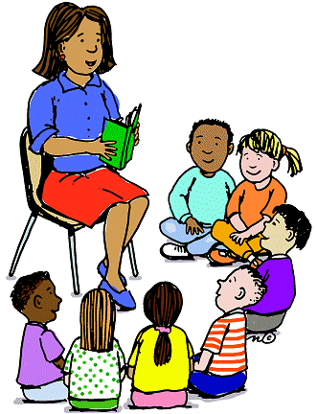  We show PRIDE in INDEPENDENT PRACTICE!  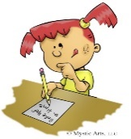 | We will follow directions the first time.  We will work quietly and not disturb others.  We will keep hands, feet and objects to ourselves.  We will raise our hands to speak or leave our seats.  We will respect personal and school property.  If there is a problem, report it to the teacher.

What will happen if YOU follow the rules? | Individual  Earn Paws for the PBIS store |  | Whole Group  Ice cream party  Popcorn and Movie  Extra Recess  Just Dance
What happens when YOU do not follow the rules?  (minor behaviors) | 1st Infraction | 2nd Infraction | 3rd Infraction | 4th Infraction | 5th Infraction
Speaking out of turn or disrespectfully. | Verbal Warning | Silent Lunch | Time Out | Call Home | Office Referral
Refusing to stay in space. | Verbal Warning | Silent Lunch | Time Out | Call Home | Office Referral
Is Non-Compliant (doesn’t follow directions) | Verbal Warning | Silent Lunch | Time Out | Call Home | Office Referral
Touching others inappropriately. | Verbal Warning | Silent Lunch | Time Out | Call Home | Office Referral
Taking others’ property without permission | Verbal Warning and return property/Write apology letter | Silent Lunch and return property/Write apology letter | Time Out and return property/Write apology letter | Call home and return property/Write apology letter | Office Referral

